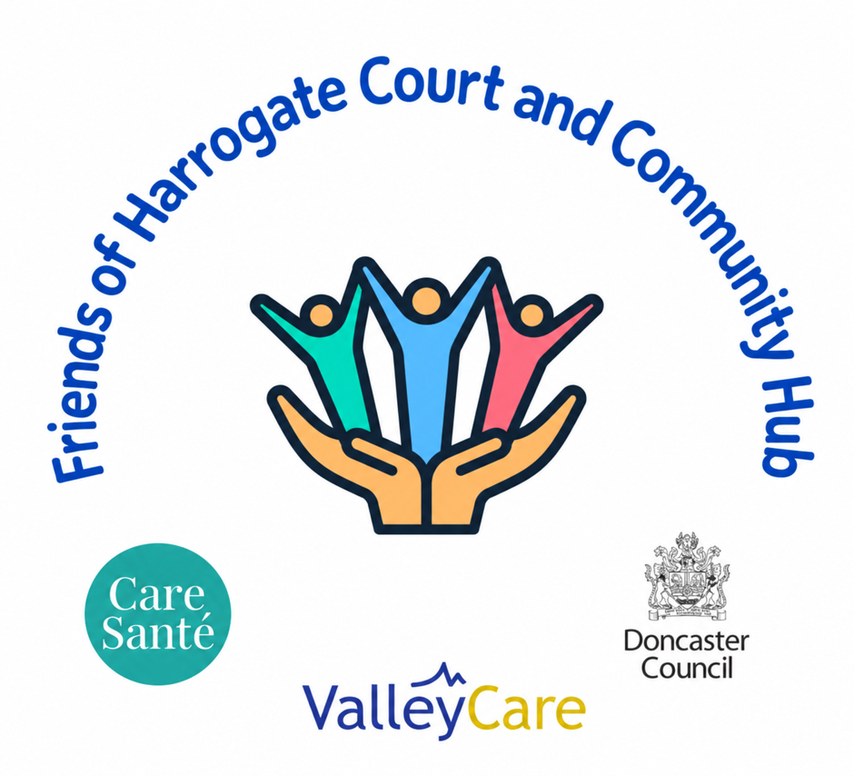 | Our Vision for Our Pantry  The Little Village Shop and Pantry | 
A volunteer led community pantry for Harrogate Court and the wider DN12 area
Why we are doing this
We are a small group of local volunteers who live in and around Harrogate Court and the wider DN12 area. Many of us have watched our community change over the years. We see neighbours struggling with the cost of food, energy and everyday living, and we also see how hard it can be for people to ask for help.
A friendly local shop
That is why we want to start a pantry that feels different. We want it to feel like a friendly local shop where people are greeted by name, treated with respect and able to choose food for themselves. We are not trying to create a handout; we are trying to create a place where people feel comfortable walking through the door.
When and where
The pantry will run from the shop at Harrogate Court and will be led by volunteers from the community and the tenants who live there. We plan to open on Monday, Wednesday and Friday, with a morning session from 9am to 11am and an afternoon session from 1pm to 3pm. These times give local people several opportunities each week to visit while remaining manageable for our volunteers.
Privacy and dignity
One thing that matters to us is privacy. Some people tell us they avoid food support because they do not want others to know they are struggling. For that reason, we will operate a one in, one out system so members can shop quietly and with dignity. Two volunteers have agreed to act as privacy champions, offering confidential support to anyone facing a crisis who is unable to access support through traditional routes. Sign up details will be shared with our partners at the local authority to support the delivery and monitoring of the pantry, but not elsewhere.
A pantry that belongs to everyone
We also want the pantry to belong to everyone. We are including an accessible till counter on wheels so wheelchair users can volunteer alongside everybody else. We believe local people should have the chance to help shape the pantry, not just receive support from it.

Our Vision for Our Pantry continued
Working together
We are fortunate to be working with Well Doncaster, the TARA group, our housing provider and Valley Care by Care Sante. Valley Care by Care Sante has kindly offered food hygiene training, PPE and volunteer support as part of its social value contribution, which means more funding can go directly into food, equipment and community delivery.
Our longer term hope
Our longer term hope is that the pantry becomes a trusted part of everyday life in DN12. If a neighbour is having a difficult month, they can come to the pantry without feeling judged. If a local business has good food that would otherwise go to waste, it can stay in the community. If a resident wants to give something back, they can volunteer and be part of something positive.
More than food
For us, this project is about more than food. It is about rebuilding connections, reducing isolation and creating a community where people look out for one another again.
Join us online  Read our vision, see membership details and complete the sign up form at:  https://friendsofharrogatecourt.co.uk | 

